**Steps to create SQL Connection through JDBC in eclipse**

For creating connection of SQL to eclipse, you should have SQL SERVER DATABASE in your systems. Please download it from Microsoft site.

**Please follow below steps to download the SQL Server**

**Step 1)**Go to URL: <https://www.microsoft.com/en-in/sql-server/sql-server-downloads>

Microsoft provides **two specialized free editions** to work on MS SQL server:

1. **Developer** – It has all feature which MS SQL server offers but we cannot use it in production. From the learning perspective, is it an ideal candidate to start.

Express: This is also a free version but with the limited set of features with no business intelligence applications.

1. **Express**: This is also a free version but with the limited set of features with no business intelligence applications.

We will select the **Developer edition** for installation.

**Step 2)** Click on **"Download now"**

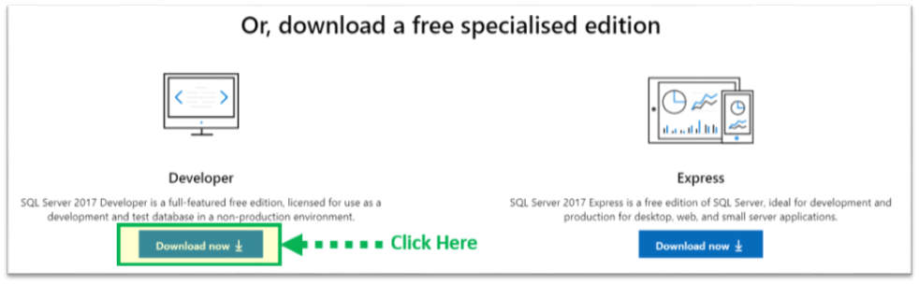

**Create an user in SQL SERVER DATABASE like below. Please find below steps to create an user and SQL server authentication**

1. Authentication mode should be : “**Window Authentication**” and Server Name should be : **SQLINSTANCE**(Make sure the SQLINSTANCE should be selected the same as created at the time of SQL installation unless it would created problem while creating connection of JDBC).

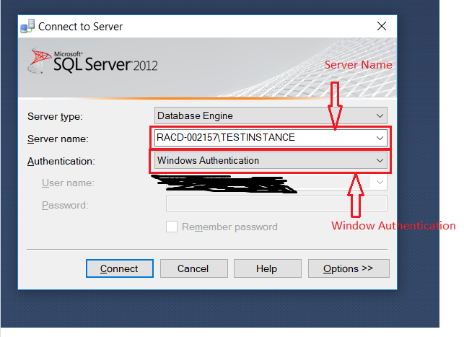

1. Click on “**Connect**” button.
2. Right Click on “**Logins**” and click on “**New Login**” option.

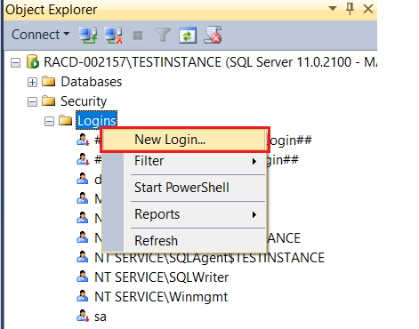

1. Go to **GENERAL** Tab --> Enter the Login name ex.. “**SQLTest1**”.
2. After, click on SQL Server authentication radio button and enter password ex.. “**SQLTest1**” for the login name.
3. Make sure “**Enforce password expiration**” and “**user must change password at next login**” must be unchecked and “**Enforce password policy**” should be checked.

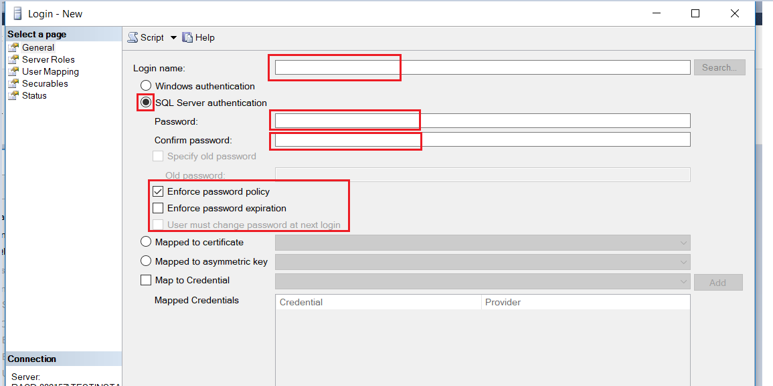

1. Now for granting access to create Databases, tables and other services. Go to “**Server Roles**” Tab and check all the unchecked boxes mentioned at below screenshot.

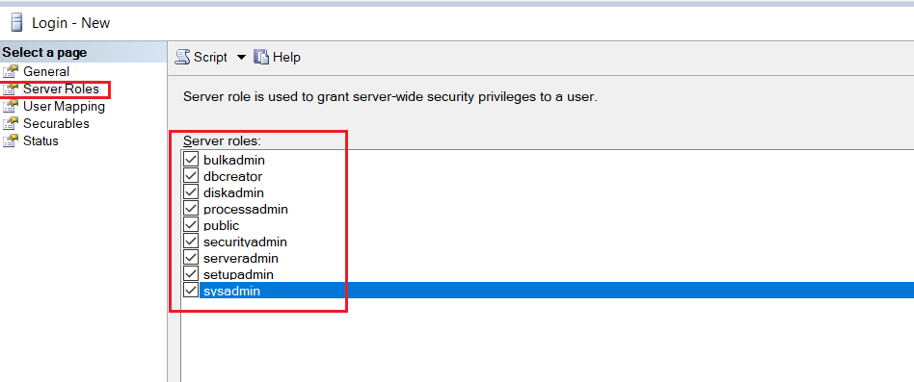

1. Make sure the radio button of “**Permission to connect to database engine**” and “**Login**” should be enabled or clicked in “**Status**” Tab

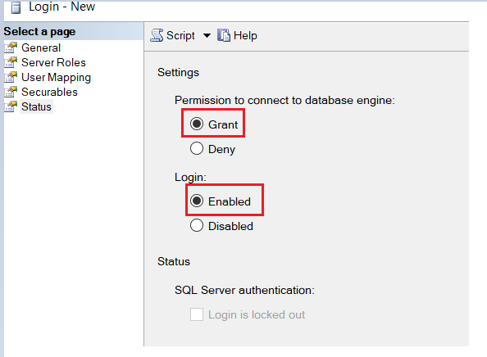

1. Now restart the SQL Server Database just right click on SQLINSTANCE and click on “**Restart**” and click on Yes button.

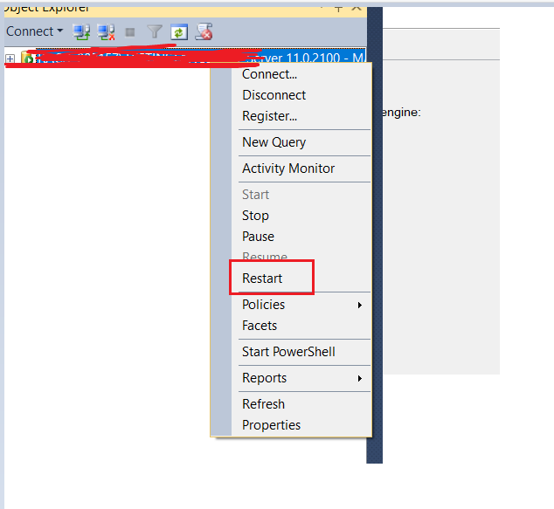

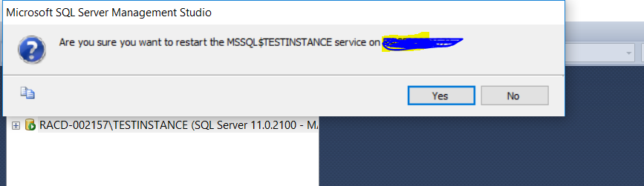

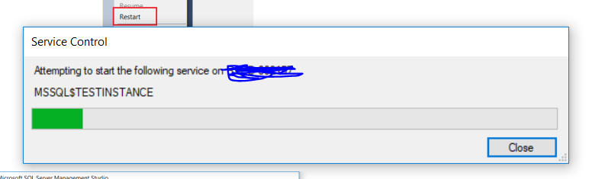

1. Now right click on your SQLINSTANCE and click on “**Connect**” and after that you will see the “Connect to server” window pop-up window. So please enter the credential for that you have created an user(SQLTest1). This time please select “**SQL Server Authentication**” option as Authentication and click on “**Connect**”. Please find below screenshot.

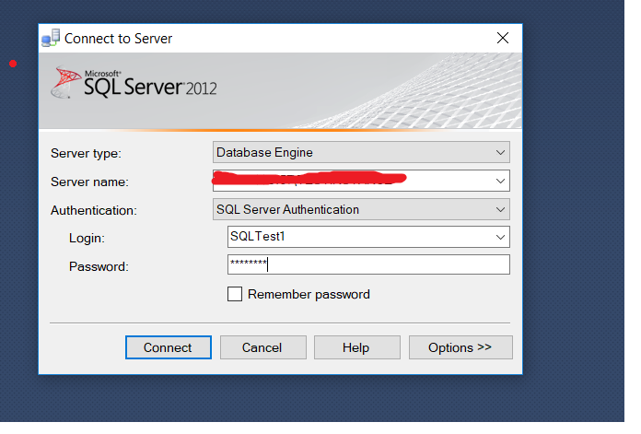

1. Now try to create and DB and Table to check if user have permission to create.

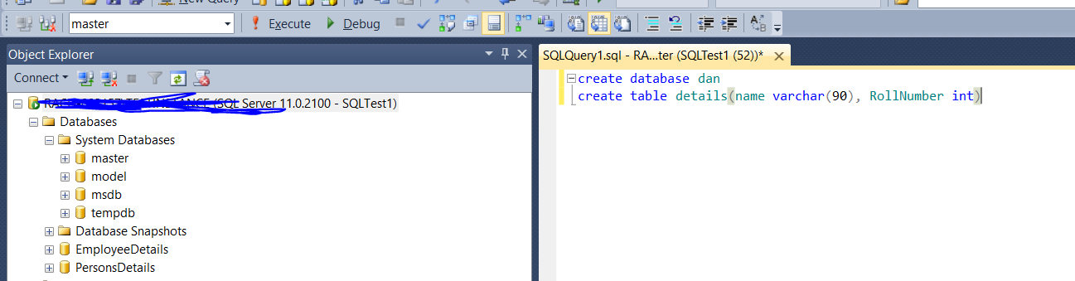

1. Finally you have created and successful user in SQL server database with granted permission of services.

**Now please find below steps to Test connection in eclipse**

Test the SQL server connection in eclipse is most important below using or connecting SQL using JDBC in eclipse. So please find below steps to Test the connection in eclipse.

1. Open eclipse and click on “**Open perspective**” icon which is present right at the corner. Please find below screenshot.

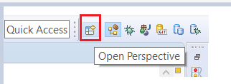

1. Select “**Database Development**” --> right click on “**Database Connections**” --> Click on “**New….**”

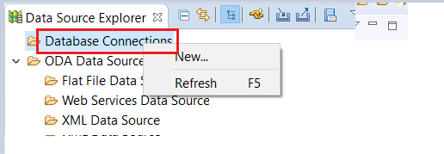

1. Select “**SQL Server**” --> Click on “**Next**”.

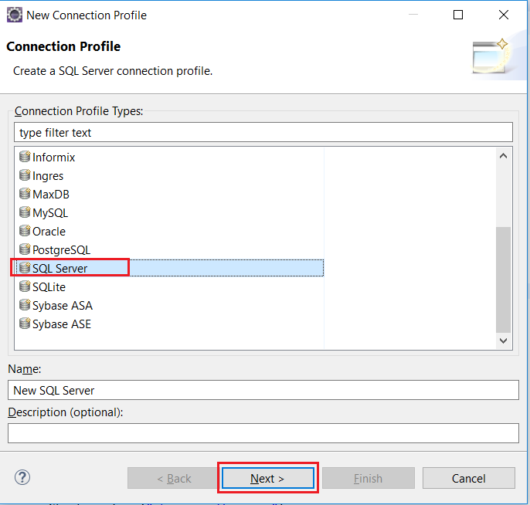

1. Now Click on “New Driver Definition” icon button



1. Now Select any driver from the list which is mentioned at below screenshot.

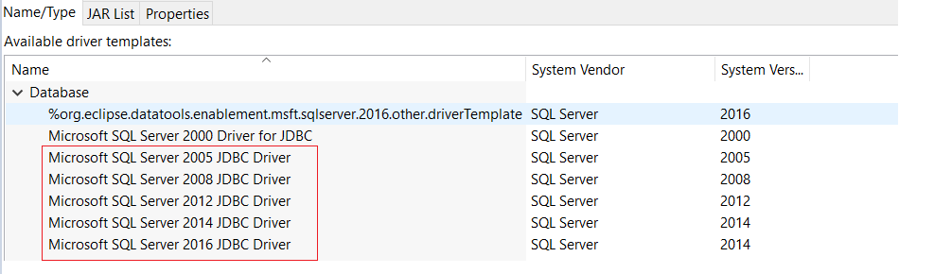

1. Please add “**Microsoft JDBC Driver for SQL Server**” the “sqldbc.jar” in **JAR list** Tab. Please download it from this link **<http://www.java2s.com/Code/Jar/s/Downloadsqljdbc420jar.htm>**

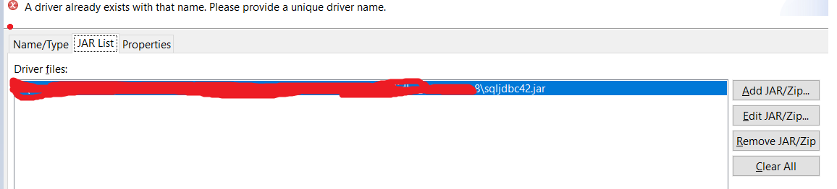

1. Please add or enter general detail in Properties Tab.Make sure the credential of **SQL server Database** and **Database name** should be same just like mentioned at below screenshot.

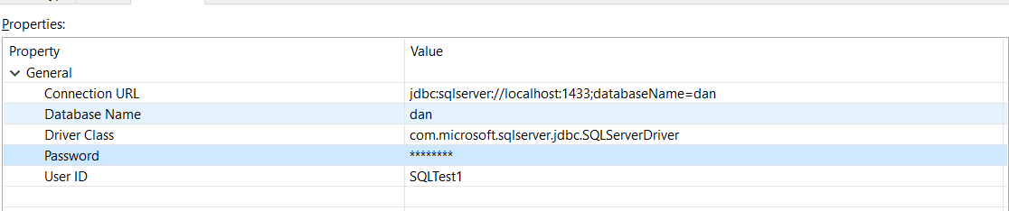

1. Once you have done this, you can test the connection by clicking the ****Test Connection**** button. If you see the ****Ping succeeded!**** message, press ****Finish**** and we are ready to go.

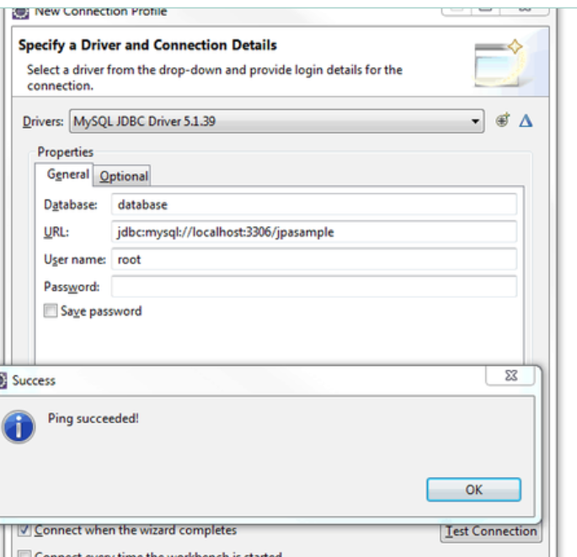

**Now to getting the URL connection please see below details :-**

URL Connection = **jdbc:sqlserver://localhost:1433;databaseName=databaseName**

**Localhost** --> Localhost should be your system hostname

Sometime you will face issue SQLConnection error while connecting SQL to eclipse and that might be because of localhost name or port name issue. We have provided the PORT access of 1433. And also please check if “**SQL Server Services**” running.

**Port-**1433 = This is the known standard for SQL Server, some organizations specify that the SQL Server port number should be changed to enhance security.

**To open a port in the Windows firewall for TCP access**

1. On the ****Start**** menu, click ****Run****, type ****WF.msc****, and then click ****OK****.
2. In the ****Windows Firewall with Advanced Security****, in the left pane, right-click ****Inbound Rules****, and then click ****New Rule**** in the action pane (upper right corner).
3. In the Rule Type dialog box, select ****Port****, and then click ****Next****.
4. In the Protocol and Ports dialog box, select ****TCP****. Select Specific local ports, and then type the port number of the instance of the Database Engine, In my case we are using the default which is ****1433****. Click ****Next****.
5. In the Action dialog box, select ****Allow the connection****, and then click ****Next****.
6. In the Profile dialog box, I am going to Leave ****Domain turned on**** and turn private and public off. Then click ****Next****.
7. In the Name dialog box, type "****Allow SQL 1433 Inbound****” and for a description I am putting in the same. Then click ****Finish****.

**Configure a Server to Listen on a Specific TCP Port**

This topic describes how to configure an instance of the SQL Server Database Engine to listen on a specific fixed port by using the SQL Server Configuration Manager. If enabled, the default instance of the SQL Server Database Engine listens on TCP port 1433. Named instances of the Database Engine and SQL Server Compact are configured for [dynamic ports](https://docs.microsoft.com/en-us/sql/tools/configuration-manager/tcp-ip-properties-ip-addresses-tab?view=sql-server-2017). This means they select an available port when the SQL Server service is started. When you are connecting to a named instance through a firewall, configure the Database Engine to listen on a specific port, so that the appropriate port can be opened in the firewall.

Because port 1433 is the known standard for SQL Server, some organizations specify that the SQL Server port number should be changed to enhance security. This might be helpful in some environments. However, the TCP/IP architecture permits a [port scanner](https://wikipedia.org/wiki/Port_scanner) to query for open ports, so changing the port number is not considered a robust security measure.

## **Using SQL Server Configuration Manager**

## **To assign a TCP/IP port number to the SQL Server Database Engine**

1. In SQL Server Configuration Manager, in the console pane, expand SQL Server Network Configuration, expand Protocols for <instance name>, and then double-click TCP/IP.
2. In the **TCP/IP Properties** dialog box, on the IP Addresses tab, several IP addresses appear in the format IP1, IP2, up to IPAll. One of these is for the IP address of the loopback adapter, **127.0.0.1**. Additional IP addresses appear for each IP Address on the computer. (You will probably see both IP version 4 and IP version 6 addresses.) Right-click each address, and then click Properties to identify the IP address that you want to configure.
3. If the TCP Dynamic Ports dialog box contains 0, indicating the Database Engine is listening on dynamic ports, delete the 0.

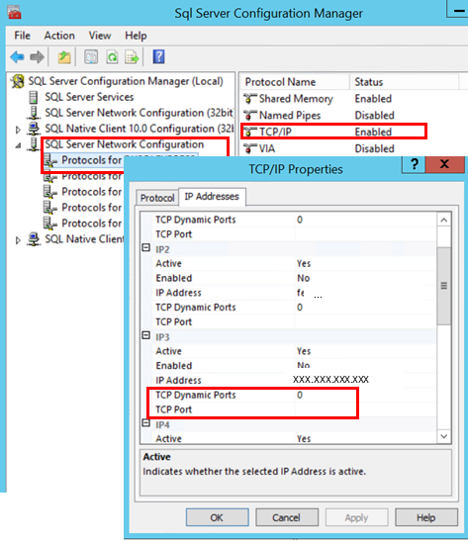

1. Please enter the portal number 1433 which is mentioned at below screenshot.

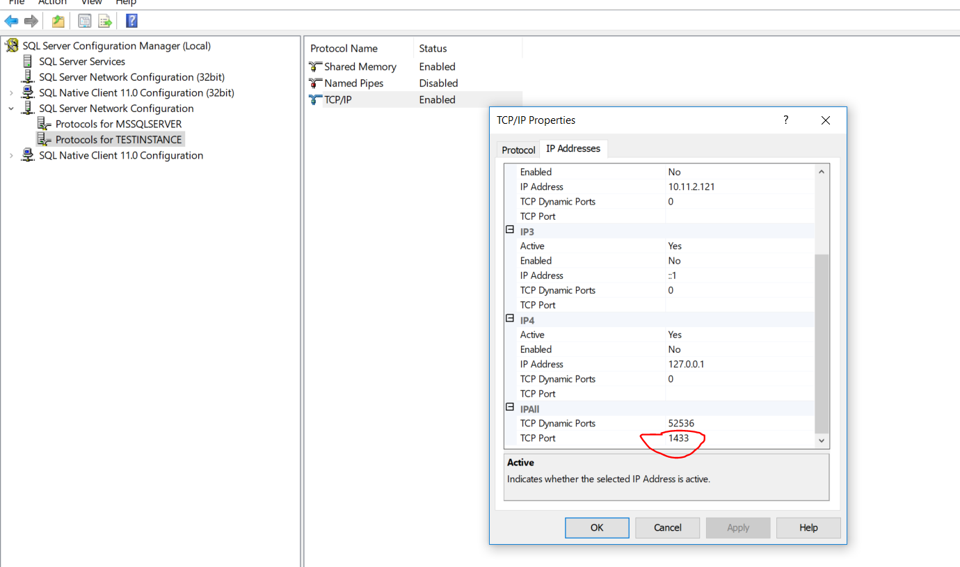

1. **Now, SQL Server Services --> SQL Server(INSTANCE) --> Right click and restarted the server**
2. Now you can right a program of JDBC in eclipse.